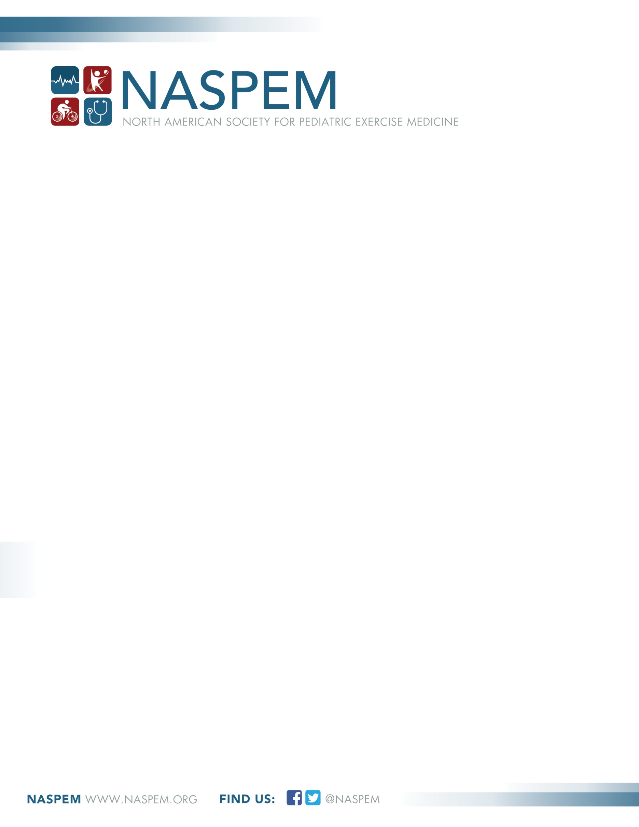

Call For Proposals
2024 Marco Cabrera Student Research Award

ELIGIBILITY
- Applicants for the student research award must have student status during the term of the award to be considered for funding.
- Applicants must be current members of NASPEM at the time of submitting the application.
- A student may submit only one application.
- The award program is open to all NASPEM student members, including international student members.
- The proposed research must align with the mission of NASPEM:
To promote exercise science, physical activity and fitness in the health and medical care of children and adolescents.

SUBMISSION PACKET
The following are required:
  - Research Proposal (limited to 5 US letter/A4 pages - 12 point, Calibri, double-line spaced) that includes the study title and each of the following sections:
(a) Background and scientific rationale for the study;
(b) Aim(s) of the study;
(c) Methods;
(d) Significance and potential impact.
- Additional required documents:
- List of references
- Timeline for completing the project (2 year maximum)– one US letter/A4 page
- Budget with justification – one US letter/A4 page
- Letter of support for the proposal from your research advisor/supervisor, who must also be a current NASPEM member and work at the same institution as you. Please note: if the total budget for your proposed research exceeds the amount awarded (maximum of $1,500 US dollars), your research advisor/supervisor must verify that the additional funds are available to you in the letter of support.

Please submit a single PDF of your proposal online at https://www.naspem.org/marco-cabrera-student-research-award/. If you have any questions about the application process, please contact info@naspem.org

DEADLINE
11:59 pm (Pacific Standard Time) May 15th, 2024
Late applications will not be accepted, regardless of the reason.

Note: We will offer an online information session to help you with your application and to answer any questions you might have. Look for the upcoming announcement on the NASPEM website.

FUNDING
Three student awards valued at $1,500, $1,250, and $1,000 US dollars will be awarded for the top three applications in rank order. Awards will only be granted pending receipt of applications that meet a minimum threshold of quality and funding availability. This award cannot be used as a source of student salary or stipend. Common uses of funds under this award include: equipment, supplies, participants’ incentives, travel to present at conferences. If you have questions, contact info@naspem.org before submission.

REVIEW PROCESS
Each proposal will be reviewed independently by two NASPEM Board members. If the two reviewers cannot agree on the quality of a proposal, an independent third reviewer will be used to arbitrate. Note: applications submitted by students of NASPEM Board members will be reviewed independently to preclude any potential bias.

Reviewers will use a rating system to evaluate the proposals on the following dimensions:
(a) Background and scientific rationale for the study;
(b) Aim(s) of the study;
(c) Methodology, including scientific approach and research design;
(d) Significance and potential impact of the proposed research.
Note: The timeline and budget are not rated specifically, but they do provide insight to the feasibility of the proposed research. It is encouraged that students propose a one-year project; however, funds will be available up to a maximum of two years. Be cognizant that the person reviewing your grant may not be a content expert, so your proposal is your best advocate for the scientific rigor and significance of your project.

NOTIFICATION
Award winners will be notified in June 2024 and announced on the NASPEM website.

ACKNOWLEDGEMENT
Recipients are strongly encouraged to present the research outcomes as a featured oral communication at a future NASPEM or European Paediatric Work Physiology (PWP) biennial conference. Recipients of the award must acknowledge NASPEM support in the presentation of their research and publications.

ADVISORY NOTE
I take this opportunity, on behalf of the NASPEM Board of Directors, to thank you for considering this award in memory of our esteemed friend and colleague, Dr. Marco Cabrera, and to wish you well with your application.

Dr. Shannon Siegel (on behalf of the Dr. Marco Cabrera Student Research Award Committee)
NASPEM President
If you have any questions, please send me a note: ssiegel@usfca.edu

